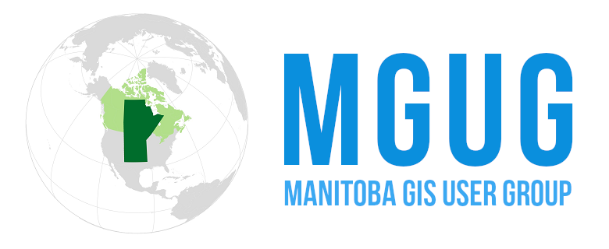**MGUG Outstanding  
GIS Project *or*  
GIS Team Award**

The Outstanding Project or Team Award recognizes exceptional contributions to the geomatics community through innovative projects or collaborative team efforts. This prestigious award celebrates initiatives that have significantly advanced the field of Geographic Information Systems (GIS), improved spatial data management, or enhanced decision-making processes through geospatial technologies. The award aims to highlight projects or teams that have demonstrated excellence in applying GIS solutions to real-world challenges, fostered interdisciplinary collaboration, or developed novel methodologies that push the boundaries of geospatial science.

* Acknowledges collaborative efforts that have pushed the boundaries of GIS applications
* Highlights projects that have made a tangible impact on communities or industries
* Recognizes excellence in project management and execution in the geospatial domain
* Project must be completed in Manitoba or by someone with a primary residence in Manitoba.
* Teams should be residing or working in Manitoba.

Nomination Process

* + Open to all members of the GIS users group
  + Peer-reviewed selection process ensures fair and thorough evaluation

Award Benefits

* + Public recognition at our annual conference
  + Featured spotlight on our website and newsletter
  + Opportunity to present work or share experiences with the GIS community
* Projects must be completed between 2023 and 2024
* Prizes include two free tickets to our annual conference

Submit this form to [info@mgug.ca](mailto:info@mgug.ca) &/or [hillssc@assiniobine.net](mailto:hillssc@assiniobine.net) **by October 18 th, 2024**

**Name of Primary Contact**: Click or tap here to enter text.

**Primary Contact Email**: Click or tap here to enter text.

**Primary Contact Phone**: Click or tap here to enter text.

**Name of Organization or Group**: Click or tap here to enter text.

**Team/Project Members**: Click or tap here to enter text.

**Project Description or Team Contribution**:

Click or tap here to enter text.