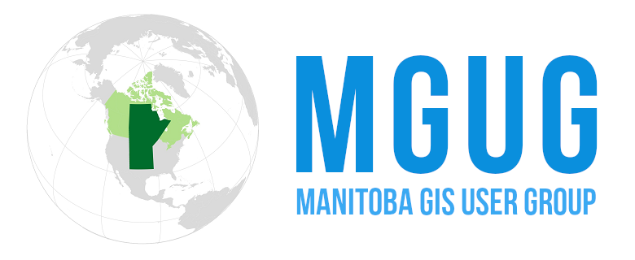

**MGUG GIS Service Recognition Award**

At the Manitoba GIS User Group (MGUG), we are dedicated to recognizing and celebrating the outstanding contributions of individuals and teams within the geomatics community.   
MGUG members are invited to nominate individuals they feel are deserving of the ***GIS Service Recognition Award***.

* Celebrates individuals who have made significant contributions to the geomatics community.
* Recognizes long-term dedication and leadership in GIS practices.
* Acknowledges innovative solutions that enhance geospatial technology.

Applications, in the form of a nomination, must include a detailed description of the nominee’s exceptional leadership, service, contributions, and passion to the geomatics community of Manitoba. Self-nominations are not accepted.

Given to an outstanding individual in Manitoba who has made significant contributions to the geomatics community:

* Demonstrated exceptional service / leadership over a significant period of time.
* Displayed a wisdom, depth of service, and passion that has made a significant difference to individuals or groups.
* Open to professionals at all career stages
* Recognizes significant contributions to the geomatics community
* Celebrates exceptional service and leadership in GIS
* Exemplified the core values of Integrity and Respect through their interaction with colleagues and the community.
* An outstanding active individual contributing to improving the work and users of the GIS/Geospatial community.
* Prizes include two free tickets to our annual conference (nominator & nominee)

Submit this form to [info@mgug.ca](mailto:info@mgug.ca) by October 18 th, 2024

**Nominator** --------------------------------------------------------------------------------------------------------------------

**Name of Nominator**:Click or tap here to enter text.

**Nominator Organization**: Click or tap here to enter text.

**Nominator Phone**: Click or tap here to enter text.

**Nominee Email:** Click or tap here to enter text.

**Nominee** --------------------------------------------------------------------------------------------------------------------------

**Name of Nominee** : Click or tap here to enter text.

**Nominee Organization(s)**: Click or tap here to enter text.

**Nominee Contact Phone**: Click or tap here to enter text.

**Nominee Email or contact info:** Click or tap here to enter text.

***Why do you feel this individual deserves the MGUG Service Recognition Award? (~250 words)***

Click or tap here to enter text.

***What are this individual’s contribution to the GIS/Geospatial Community in Manitoba? (~250 words)***

Click or tap here to enter text.

Submit this form to [info@mgug.ca](mailto:info@mgug.ca) &/or [hillssc@assiniboine.net](mailto:hillssc@assiniboine.net) by October 18 th, 2024